**Challenge 4.**



1. A quick google to see where this image is from returns Dalek a fictional violent race from doctor who, they say “Exterminate …”. No one named carlos seems to exist within this context. The images I found also appeared to be identical to the image given.
2. Inspecting the element offer something that may be a hint:



1. This empty div seems to be visible only for the admin… There is also an unused js script

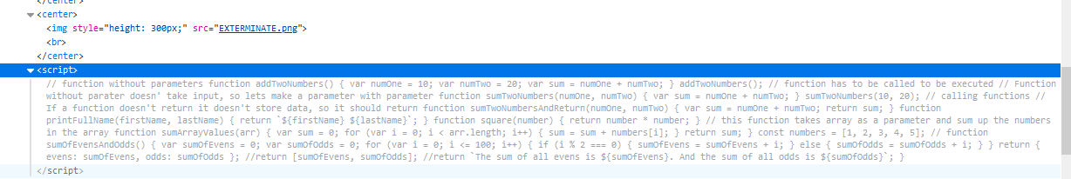

1. The javascript seems entirely useless. But it also seems like a step-by-step process. Like someone doing a tutorial in JS.

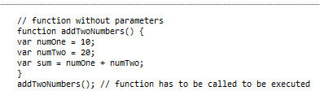

Sum = 30;

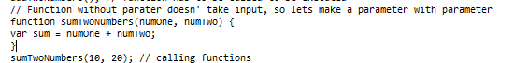

Sum = 30;

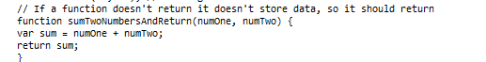

Now the value 30 is actually returned.

Then we have a whole bunch of random js functions:

* Print full name *return `${firstName} ${lastName}`;*
* Square a number
* Sum values in an array
* Sum even and odd numbers up to 100

1. I wonder if this script is actually being called or if anything is happening behind the scenes. So do a bit of poking with Burpsuite.
2. I attempted to run the JavaScript in my browser console. It doesn’t seem like it is configured correctly to be run.
3. Starting from scratch I now tried to unpack the image file. Exiftool is the first go to.

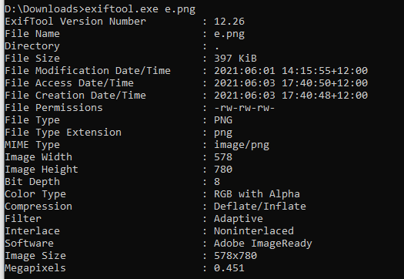

1. Next I have a look at binwalk.